# Web3py simple walkthrough

[nicozanf@gmail.com](mailto:nicozanf@gmail.com) 2019.07.13

This is a simple walkthrough of the new web3py framework (<https://github.com/web2py/web3py>) from Massimo Di Pierro. You need Python 3.5+ already installed.

In this example I’m using Windows 10, but it works fine on Linux and Mac, too.

Be aware that the framework is changing rapidly ;-)

1. Install web3py from pypi:

python3 -m pip install web3py

(if this does not work, try changing python3 with python)

NOTE: if you have already installed it, you need to clean it up before going on (delete your apps folder, upgrade web3py, and start again).

1. start it:

web3py-start myapps

(pick a one time password  and answer yes when it wants to create something, it will create myapps folder and a temp .web3py-service folder)

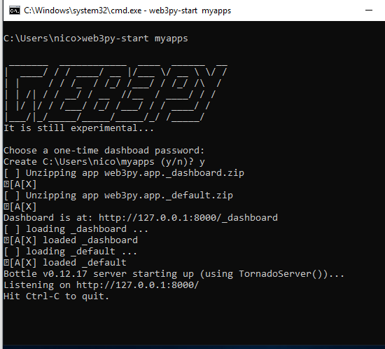

1. open the browser and goto <http://127.0.0.1:8000>

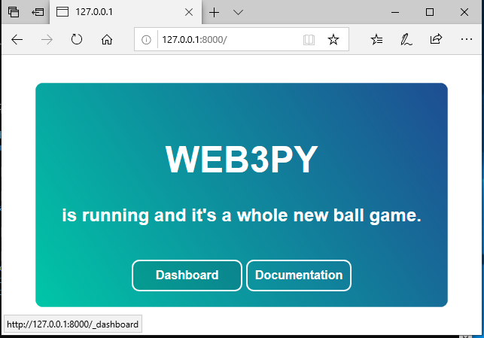

(the Documentation button is still in progress)

Click on the Daskboard button or goto:

<http://127.0.0.1:8000/_dashboard>

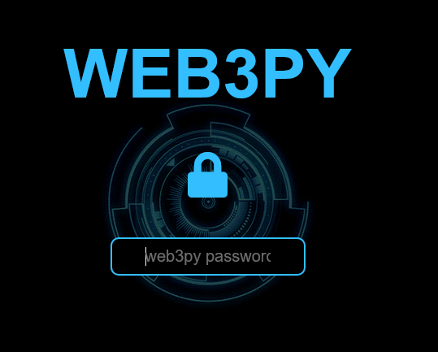

Insert the password you’ve chosen before and you’re in the Dashboard:

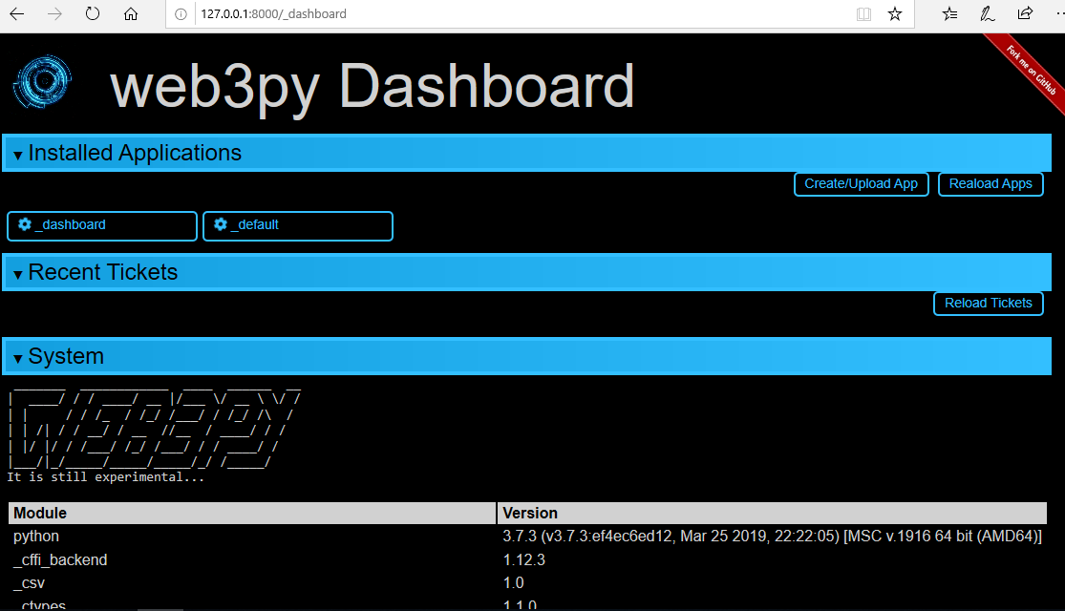

Now create a new app : click on the “Create/Upload App”:

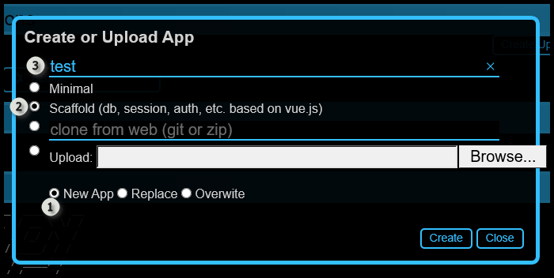

Select “New App” (1), based on the Scaffold one (2) and give it a name (3).

After pressing “Create” you will see the new app in the Dashboard:

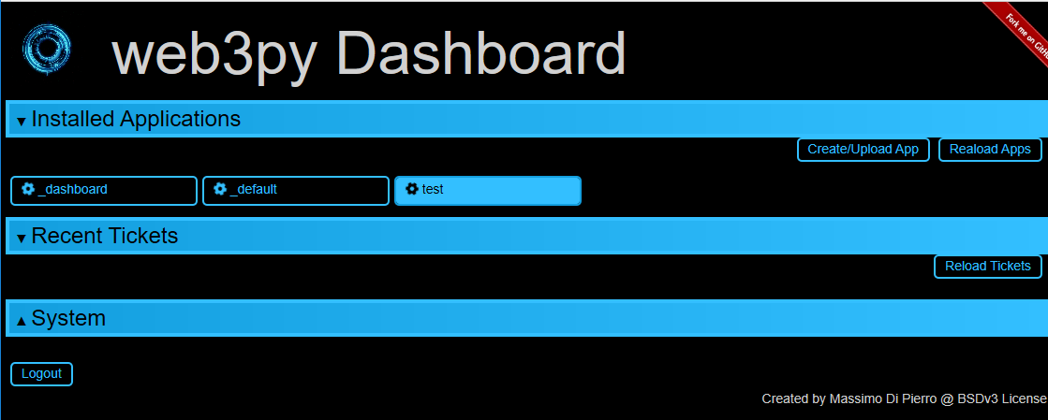

Clicking on it, you can see its properties:

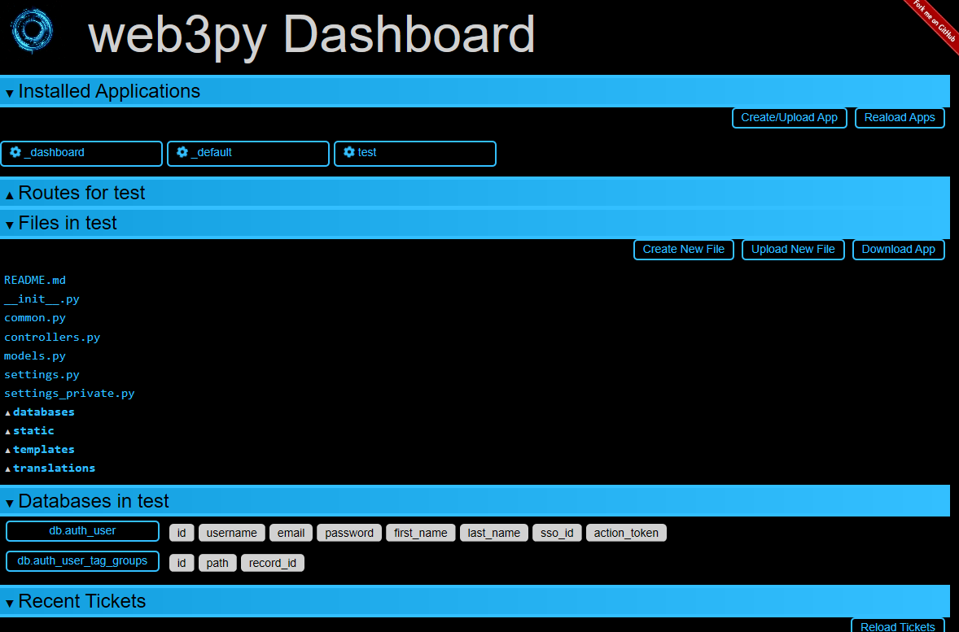

You can edit the files and databases using the embedded web editor.

Goto this new app using <http://127.0.0.1:8000/test> :

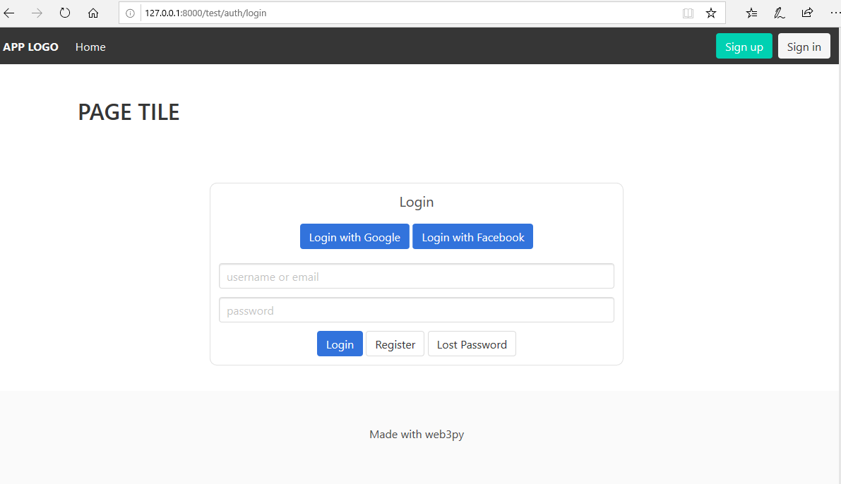

You can register as a new user and try to login:

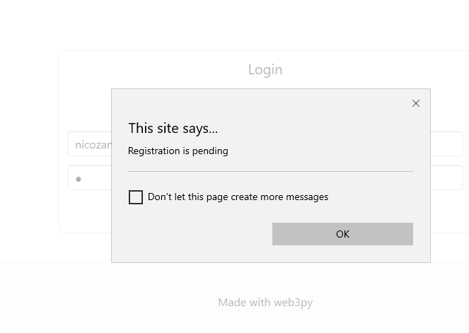

But this is still a work in progress….